Run 22 - 10 A / -100 kV, 800K particles, Deuterium

Central Anode Height
Cathode voltage | -100000.0 V (-100 kV)
Central potential (avg of x/y/z probes) | -93240.10 V
Central potential (x axis) | -93240.10 V
Central potential (y axis) | -93240.10 V
Central potential (z axis) | -93240.10 V
Central anode height | 6.760 % of |V_cathode|
Height % = (|V_cathode| - |V_centre|) / |V_cathode|. Positive value = central potential is LESS negative than the cathode (space-charge / geometric 'virtual anode' lift).

Radial Profile Extrema (z-axis, final iter)
Prominence filter: only extrema with prominence > 1000.0 V (1% of |V_cathode|) are reported to suppress mesh-resolution noise.
# | r (m) | V (V) | kind
1 | -0.0048 | -100000.00 | min
2 | +0.0006 | -93239.50 | max
3 | +0.0051 | -100000.00 | min
An interior local MAX inside the cathode (|r| < 5 mm) is a virtual-anode signature; an interior local MIN above the cathode floor is a virtual-cathode (double-well) signature.

Iter-1 (vacuum) vs Final (self-consistent) profile
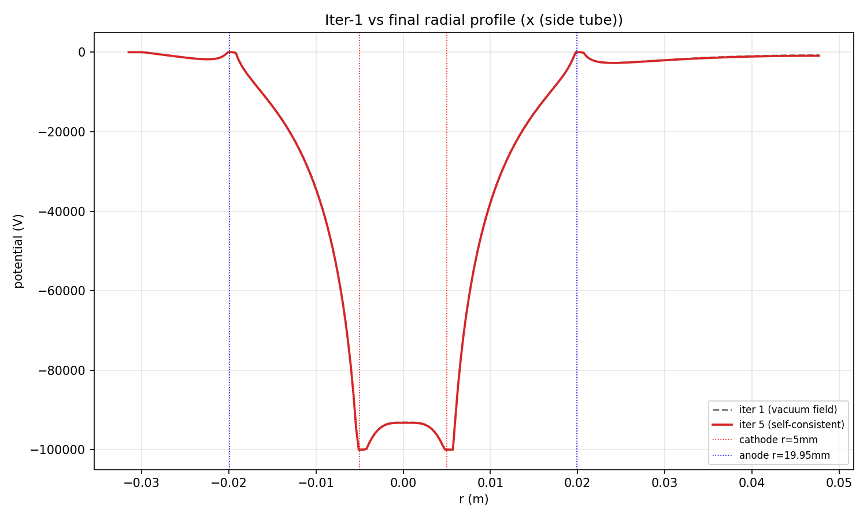
x (side tube) - gap between dashed and solid = space-charge contribution
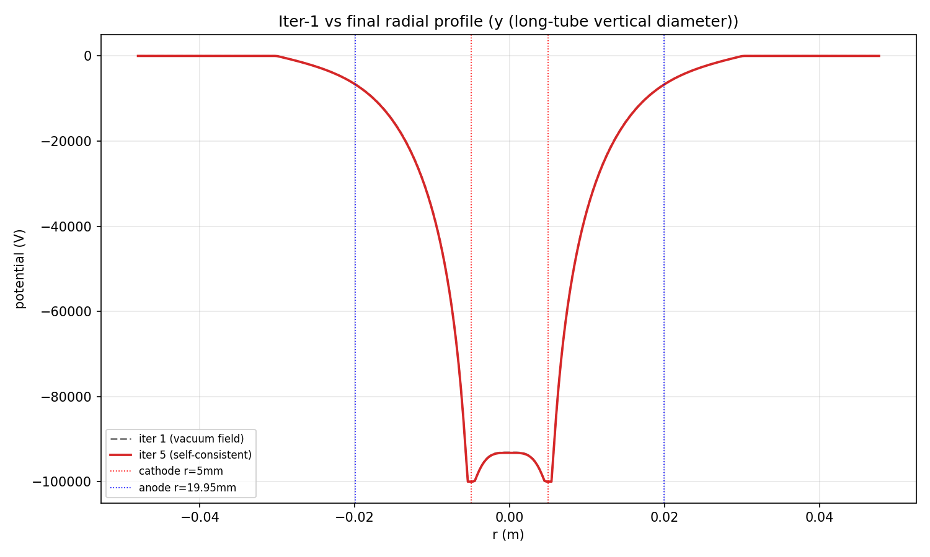
y (long-tube vertical diameter) - gap between dashed and solid = space-charge contribution
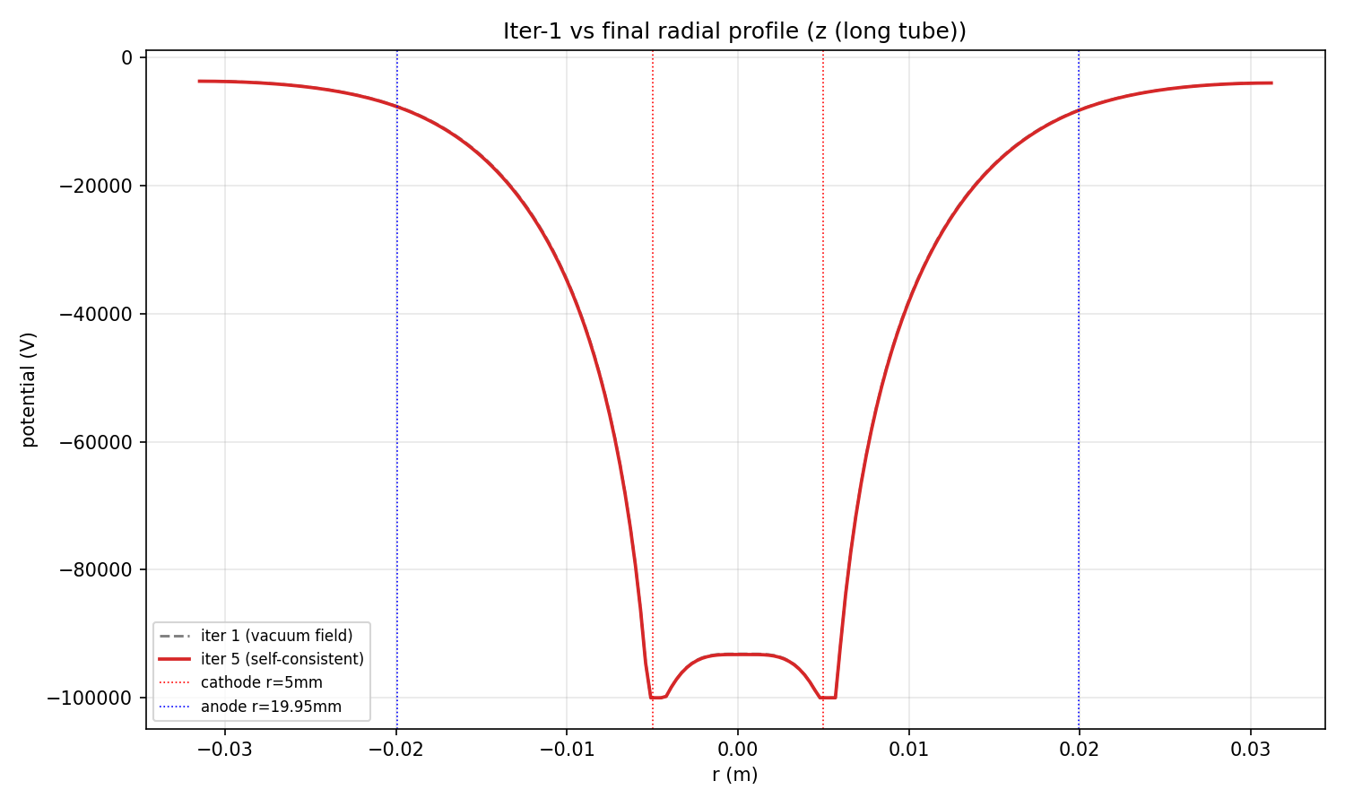
z (long tube) - gap between dashed and solid = space-charge contribution

Radial Potential Profiles
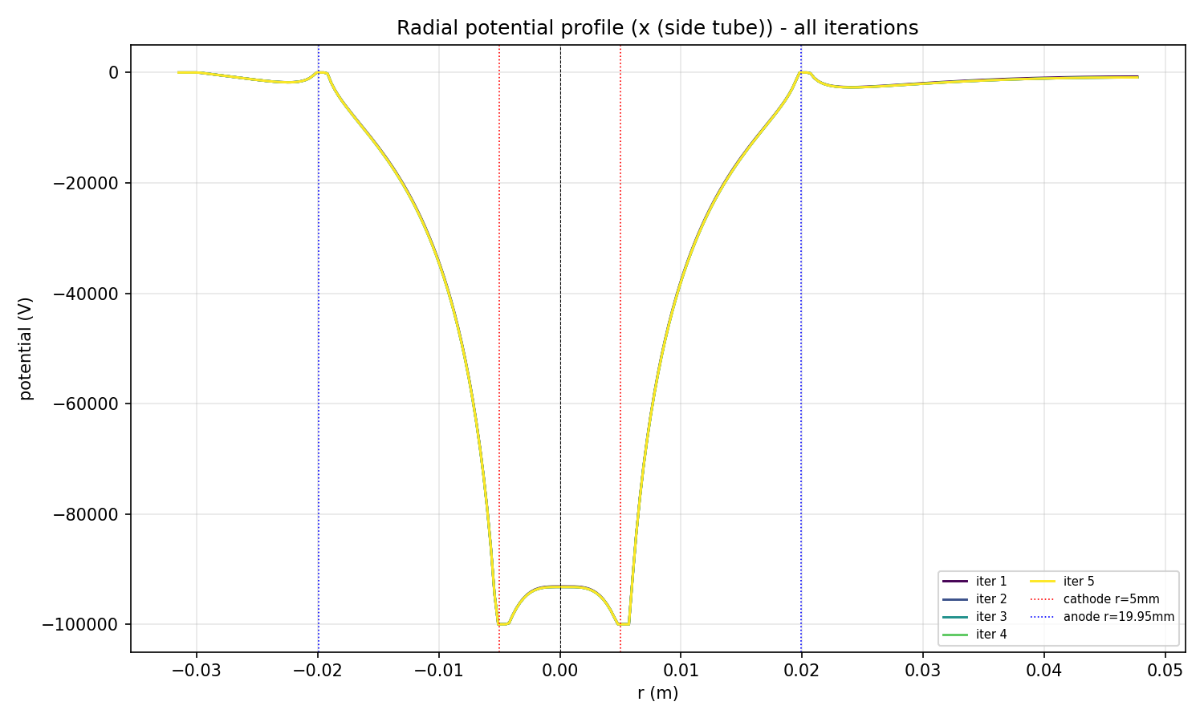
Radial potential along x (side tube), all iterations overlaid
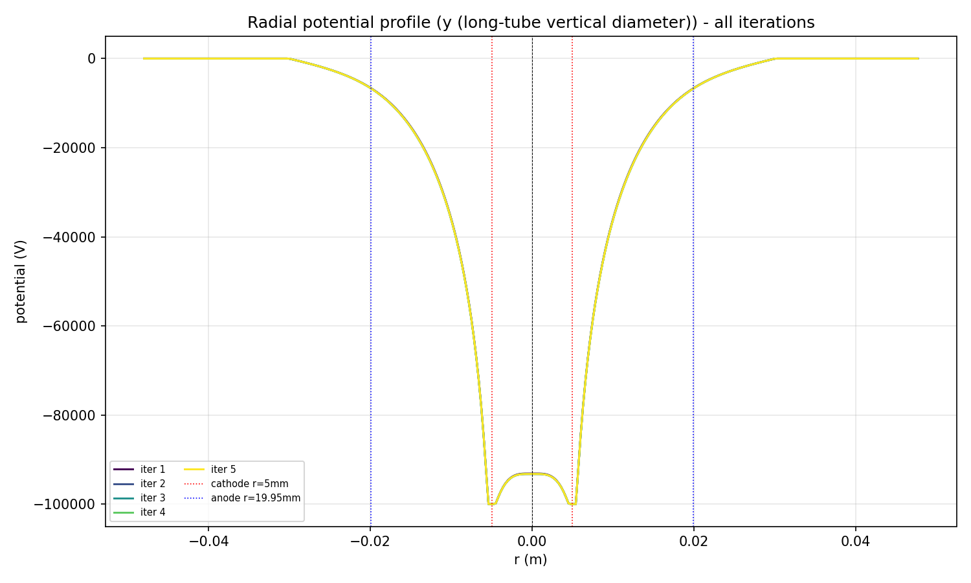
Radial potential along y (long-tube vertical diameter), all iterations overlaid
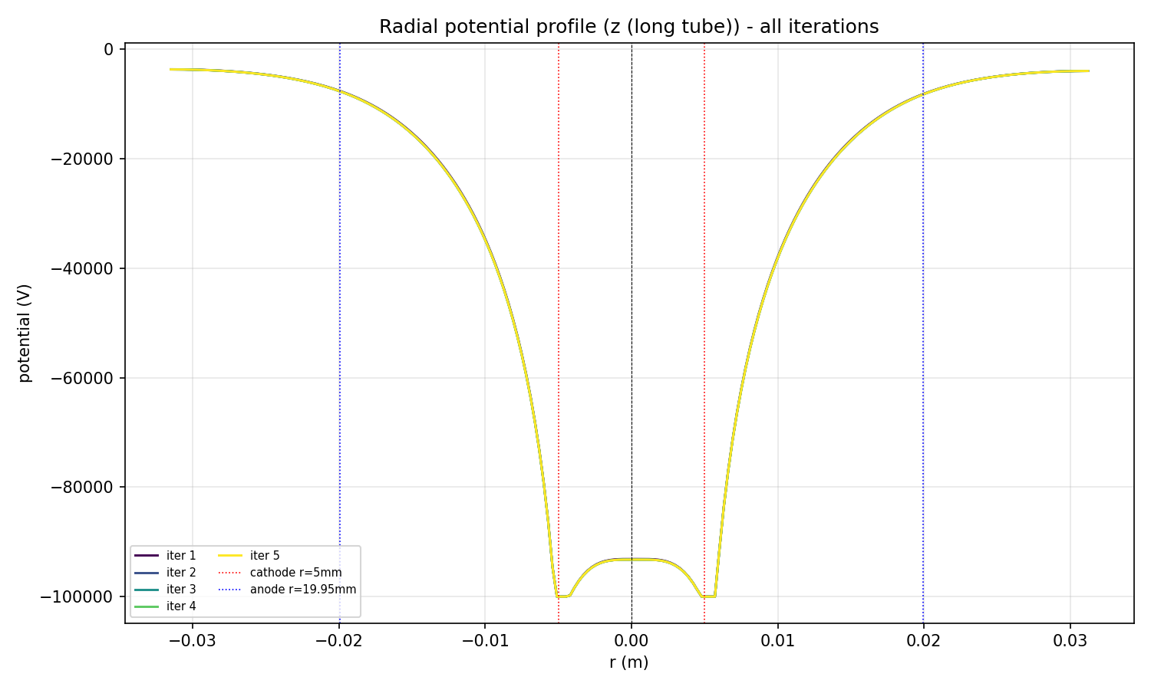
Radial potential along z (long tube), all iterations overlaid

Final Potential Field
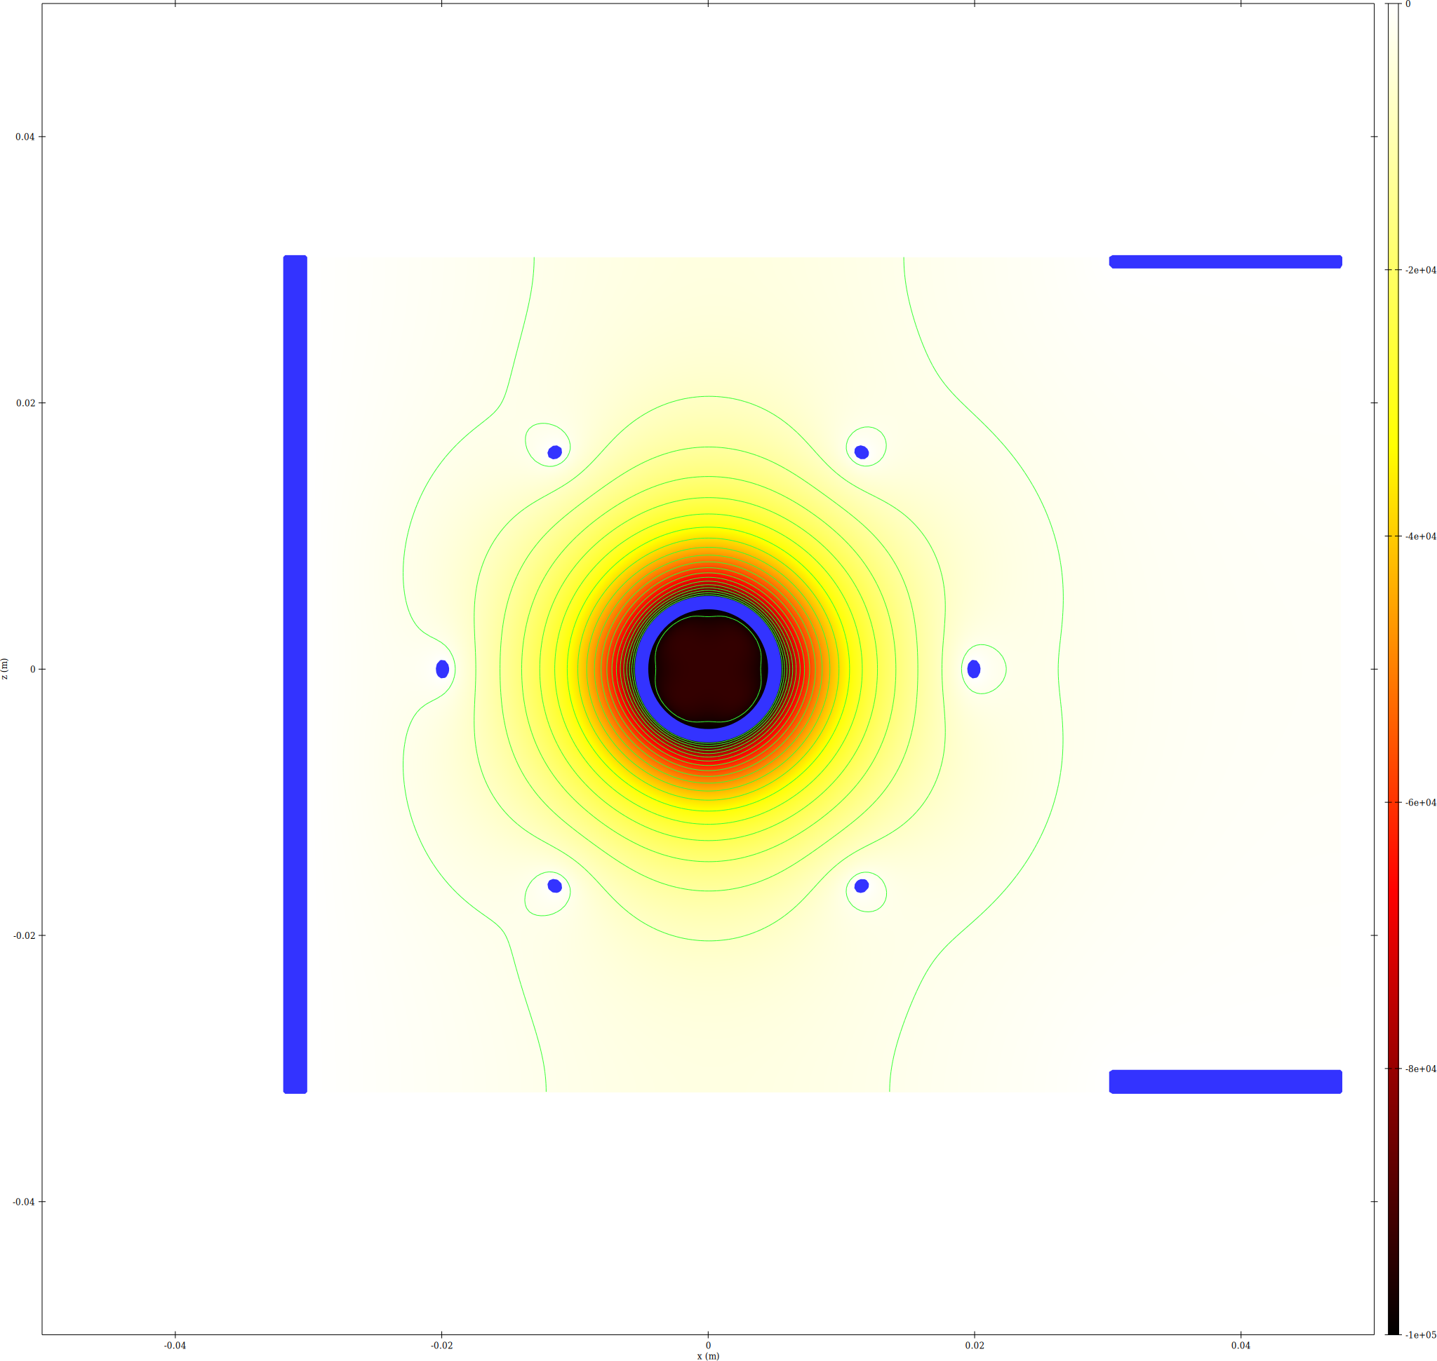
epot XZ slice
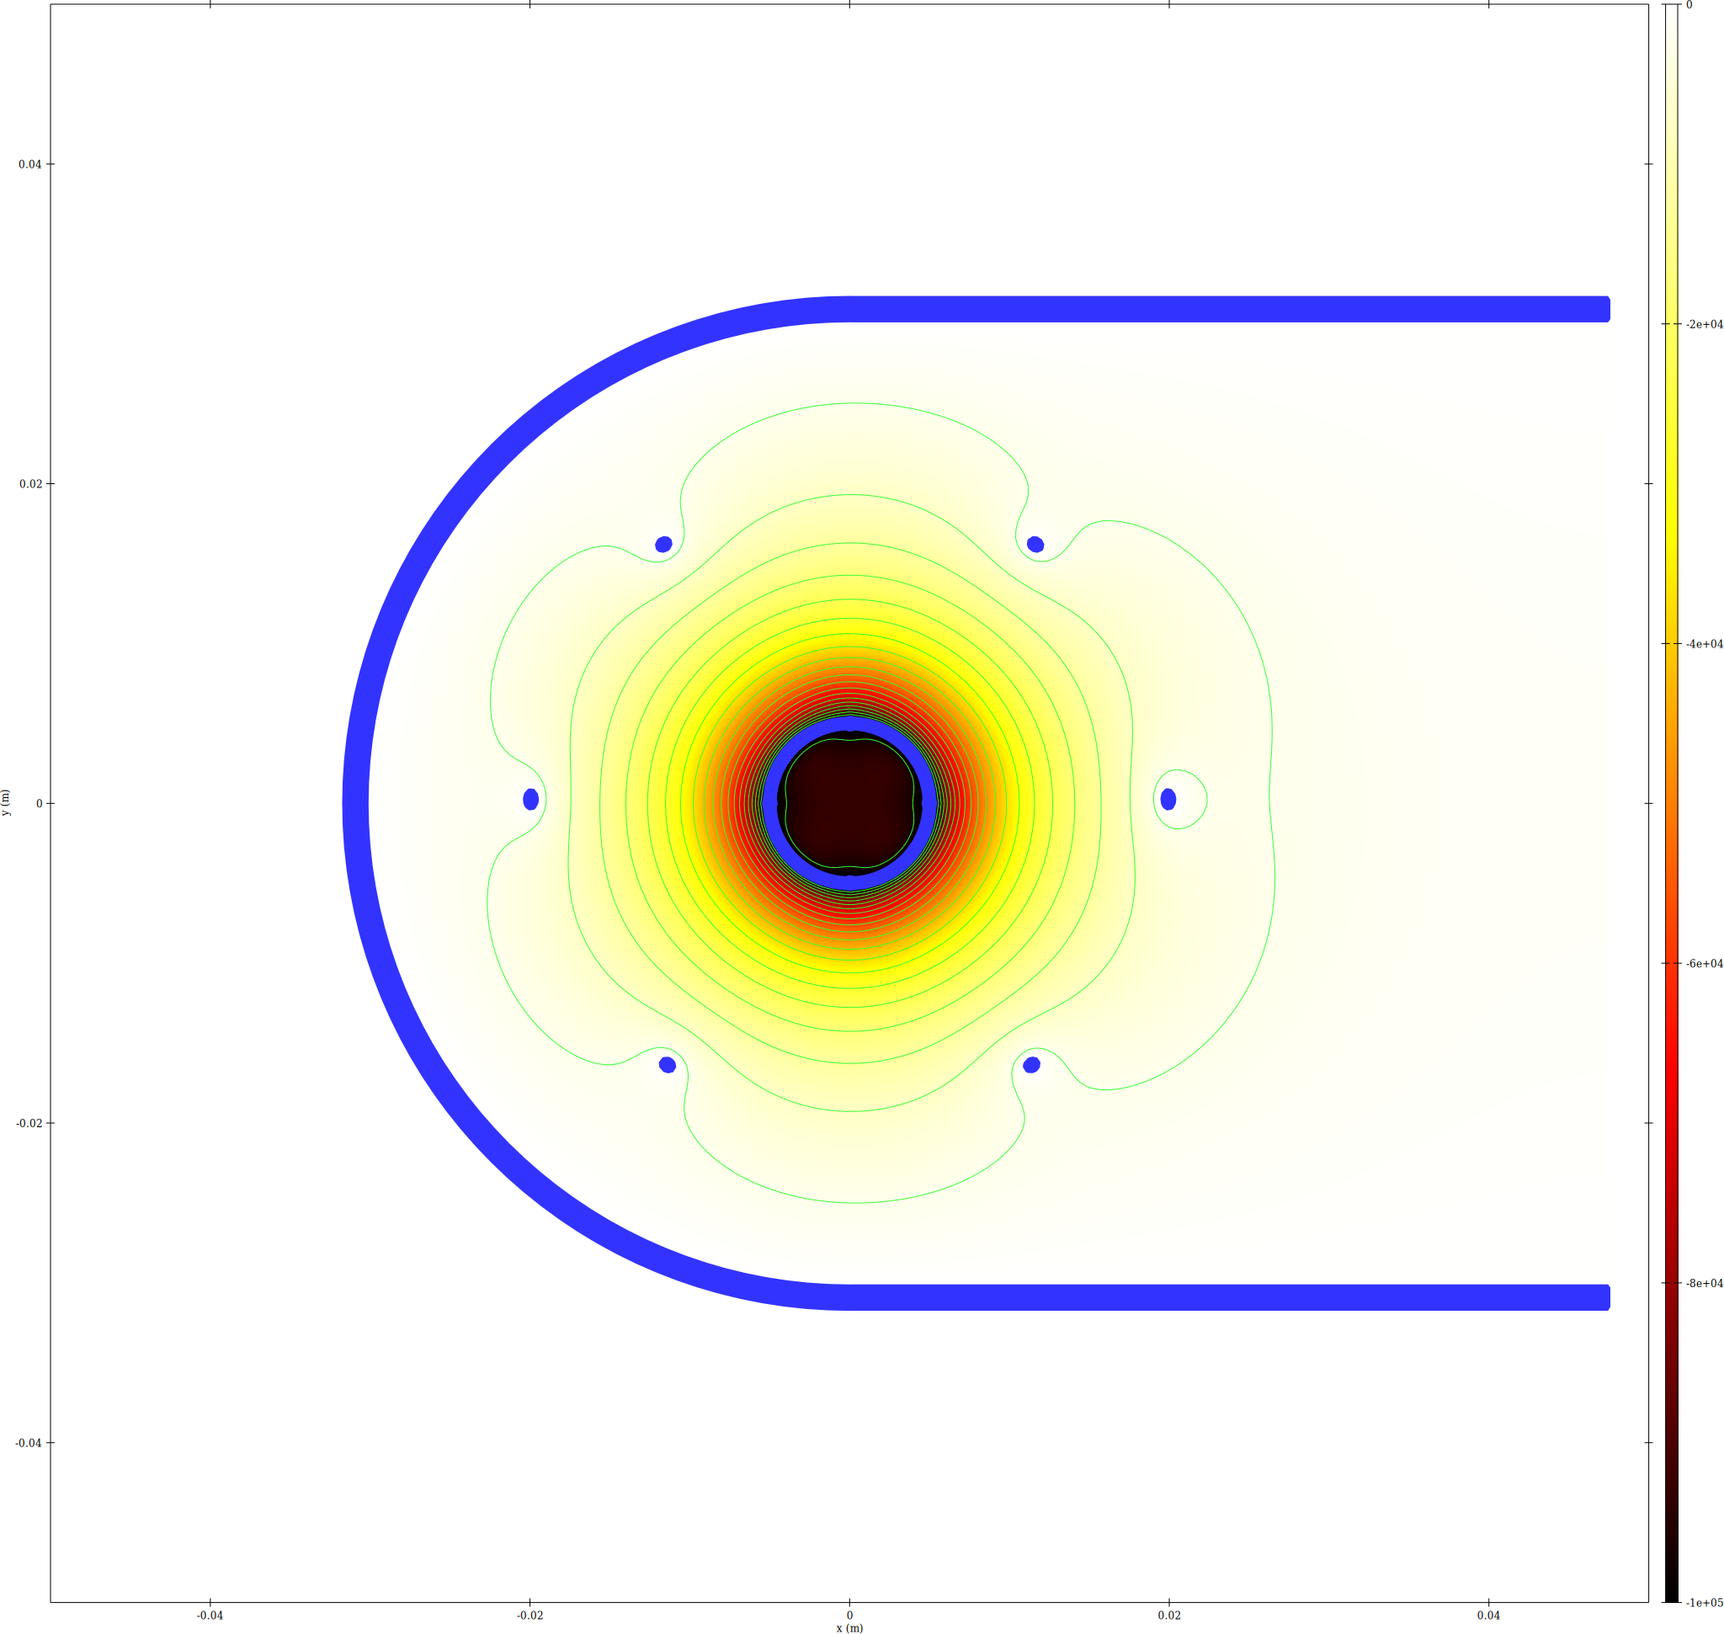
epot XY slice
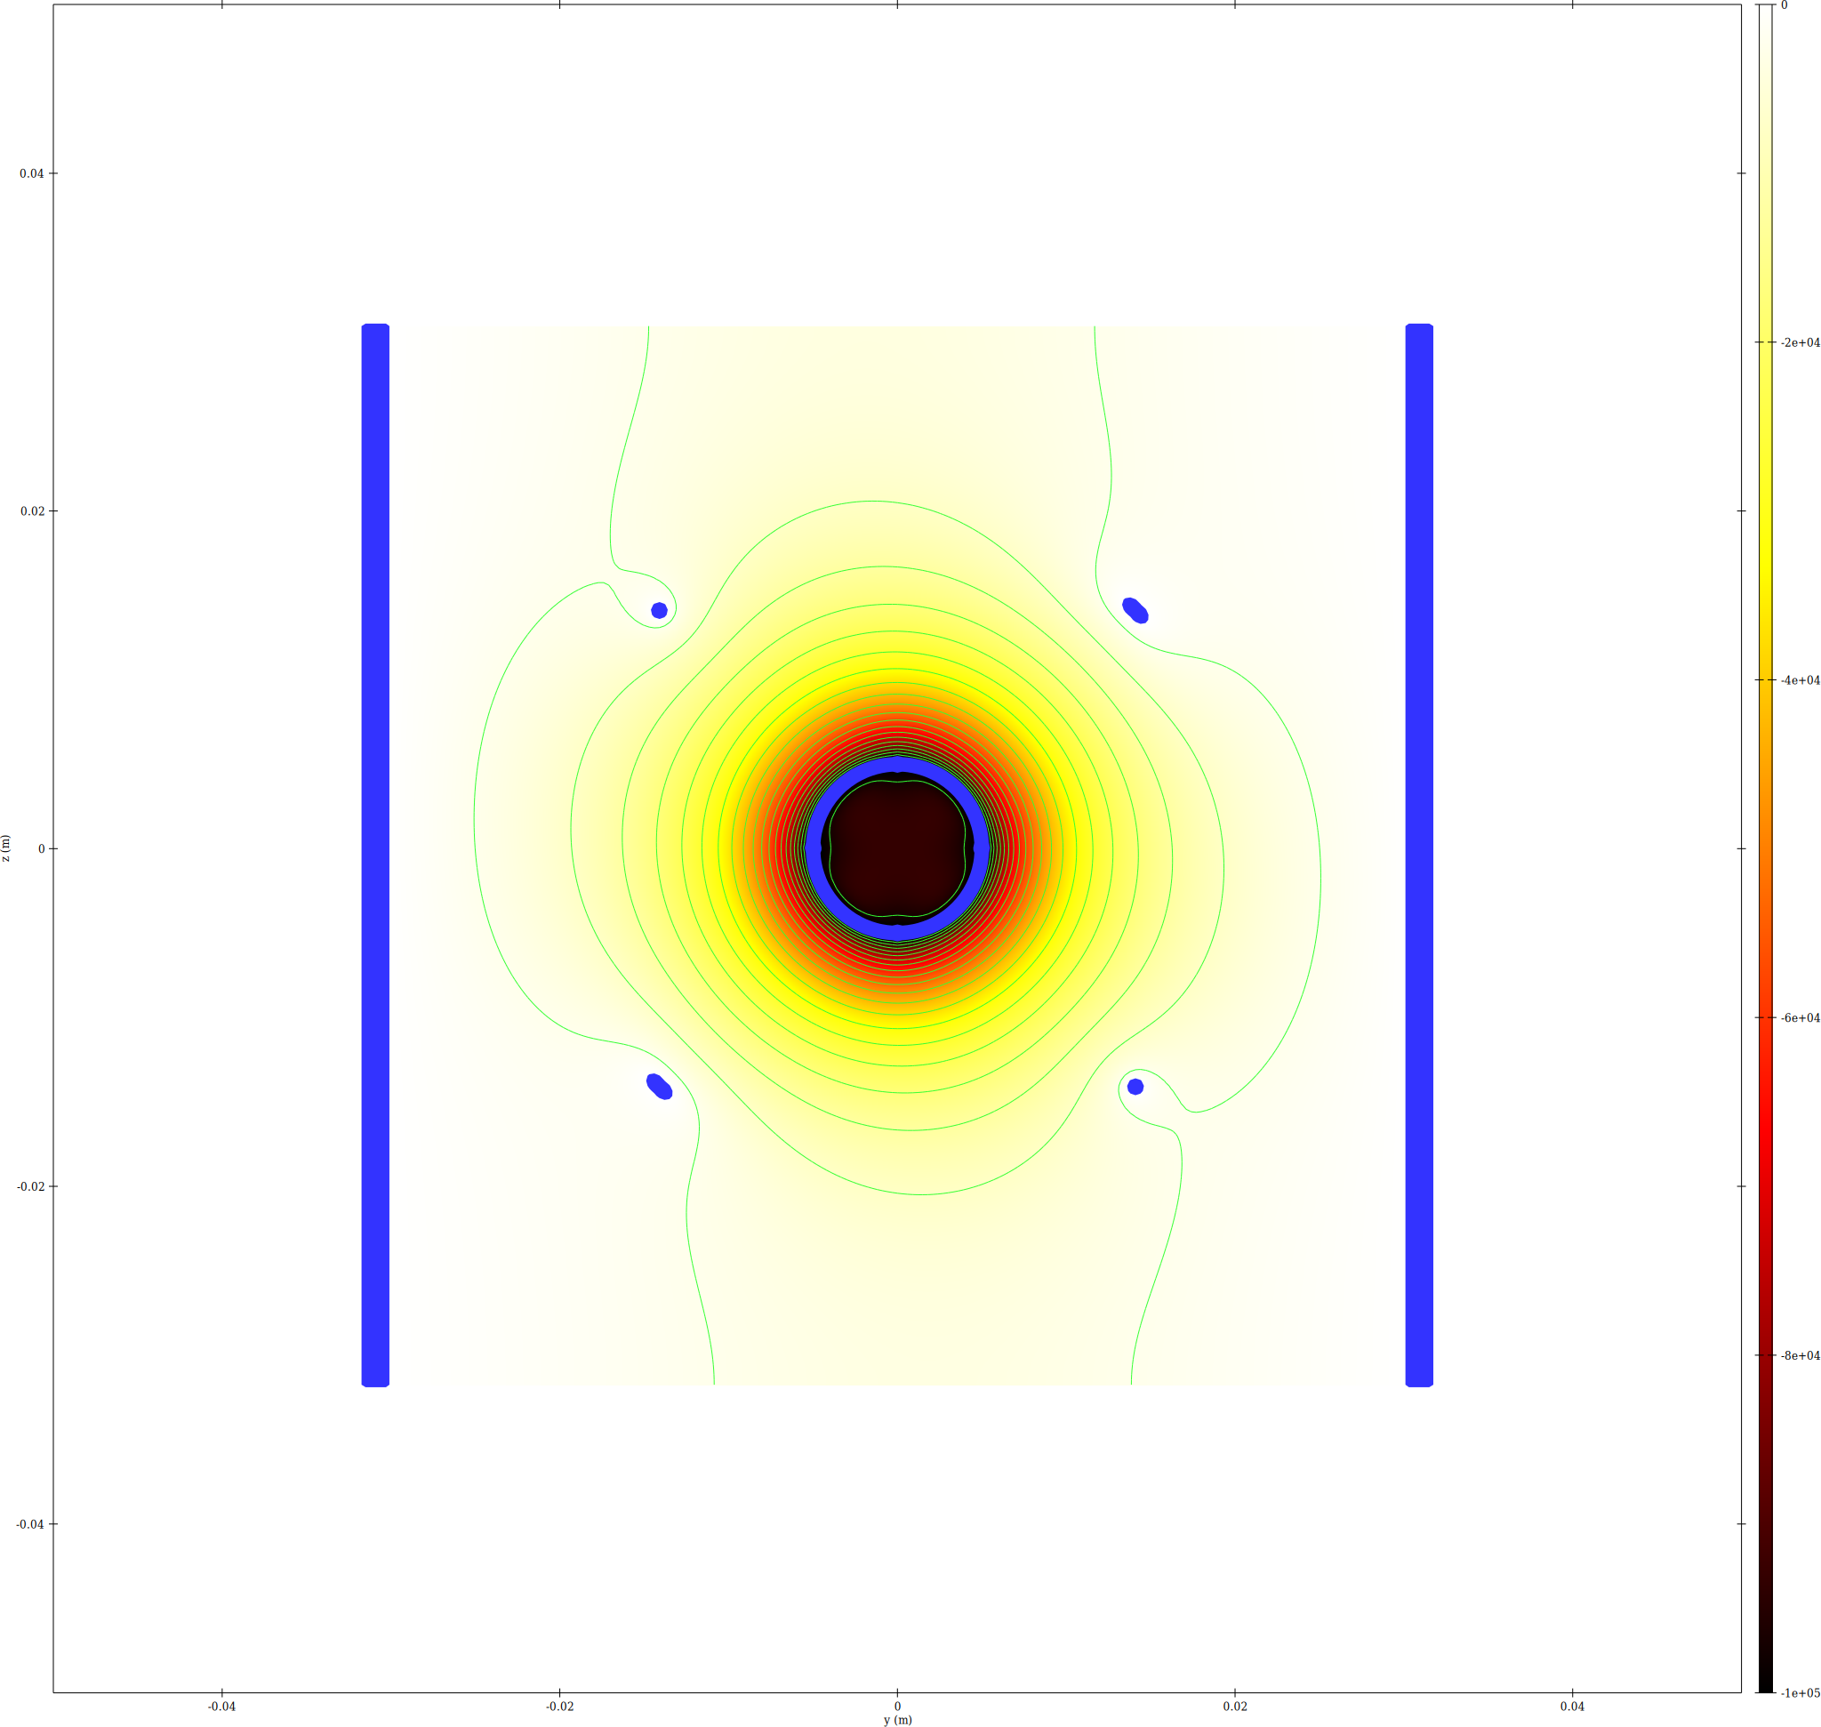
epot YZ slice at x=0

Trajectory Density

Ions
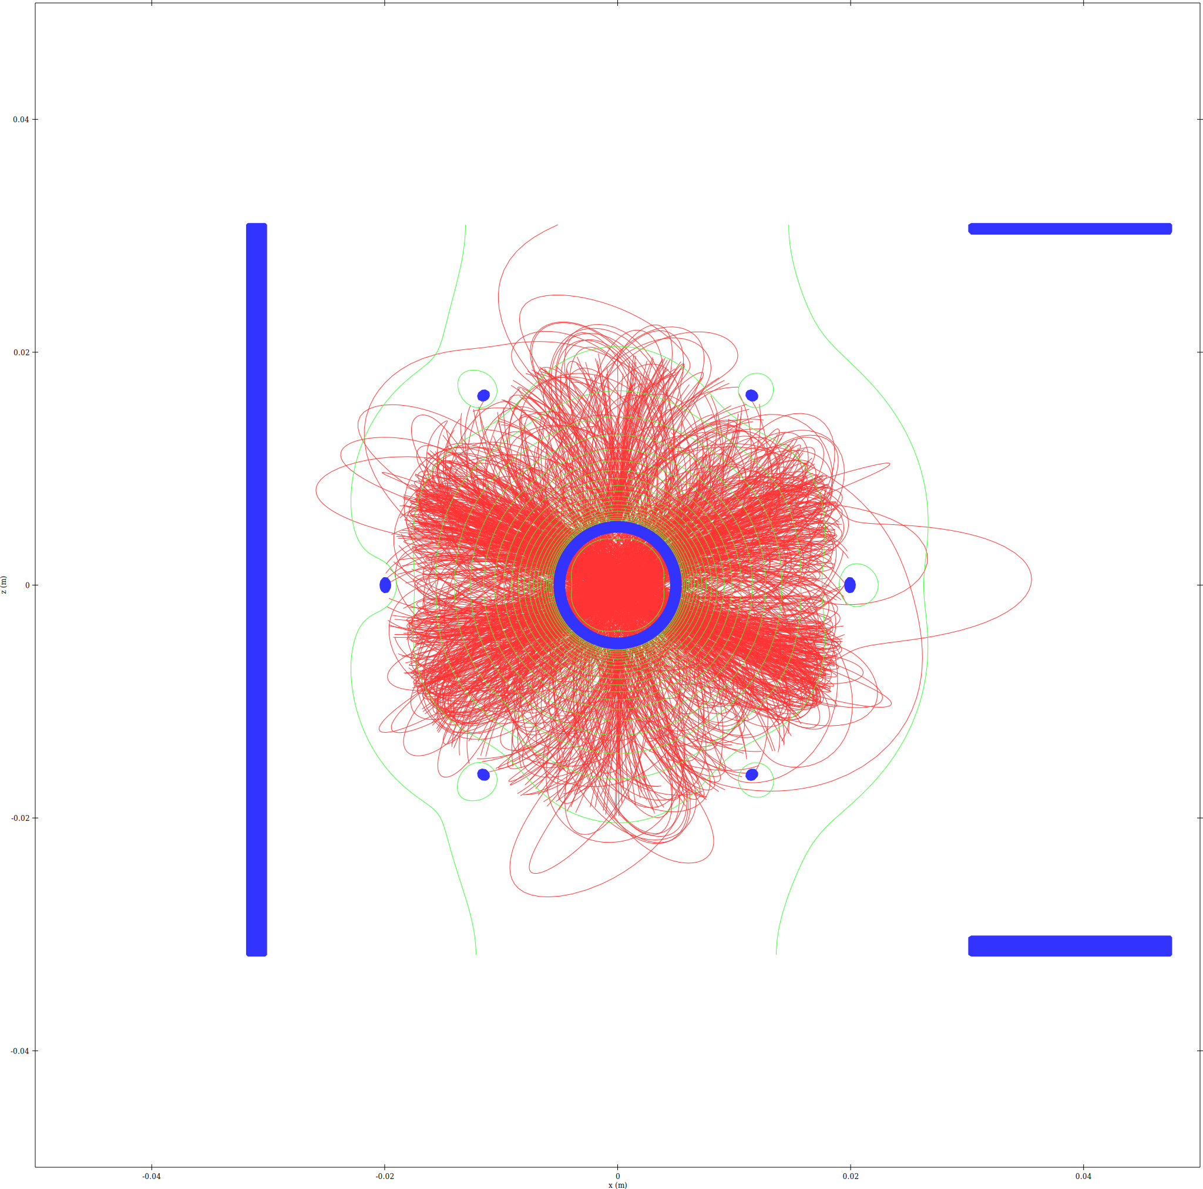
Ion trajectory density - XZ slice
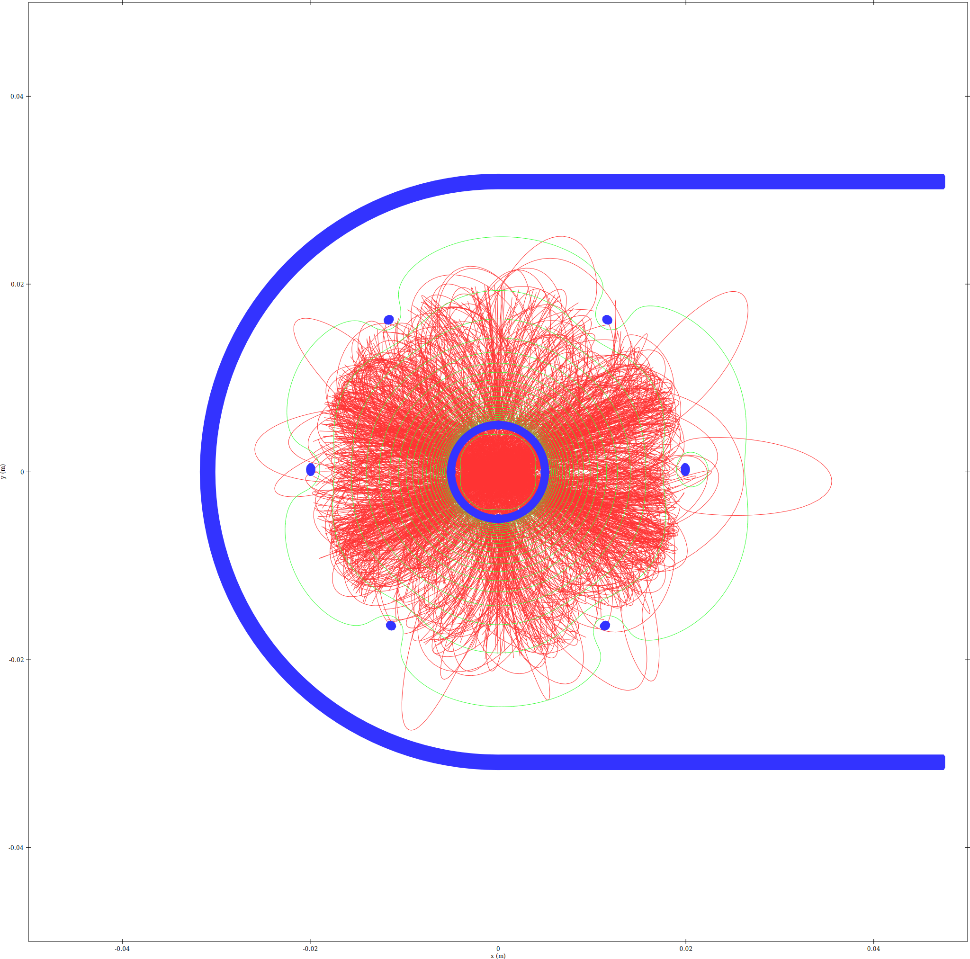
Ion trajectory density - XY slice
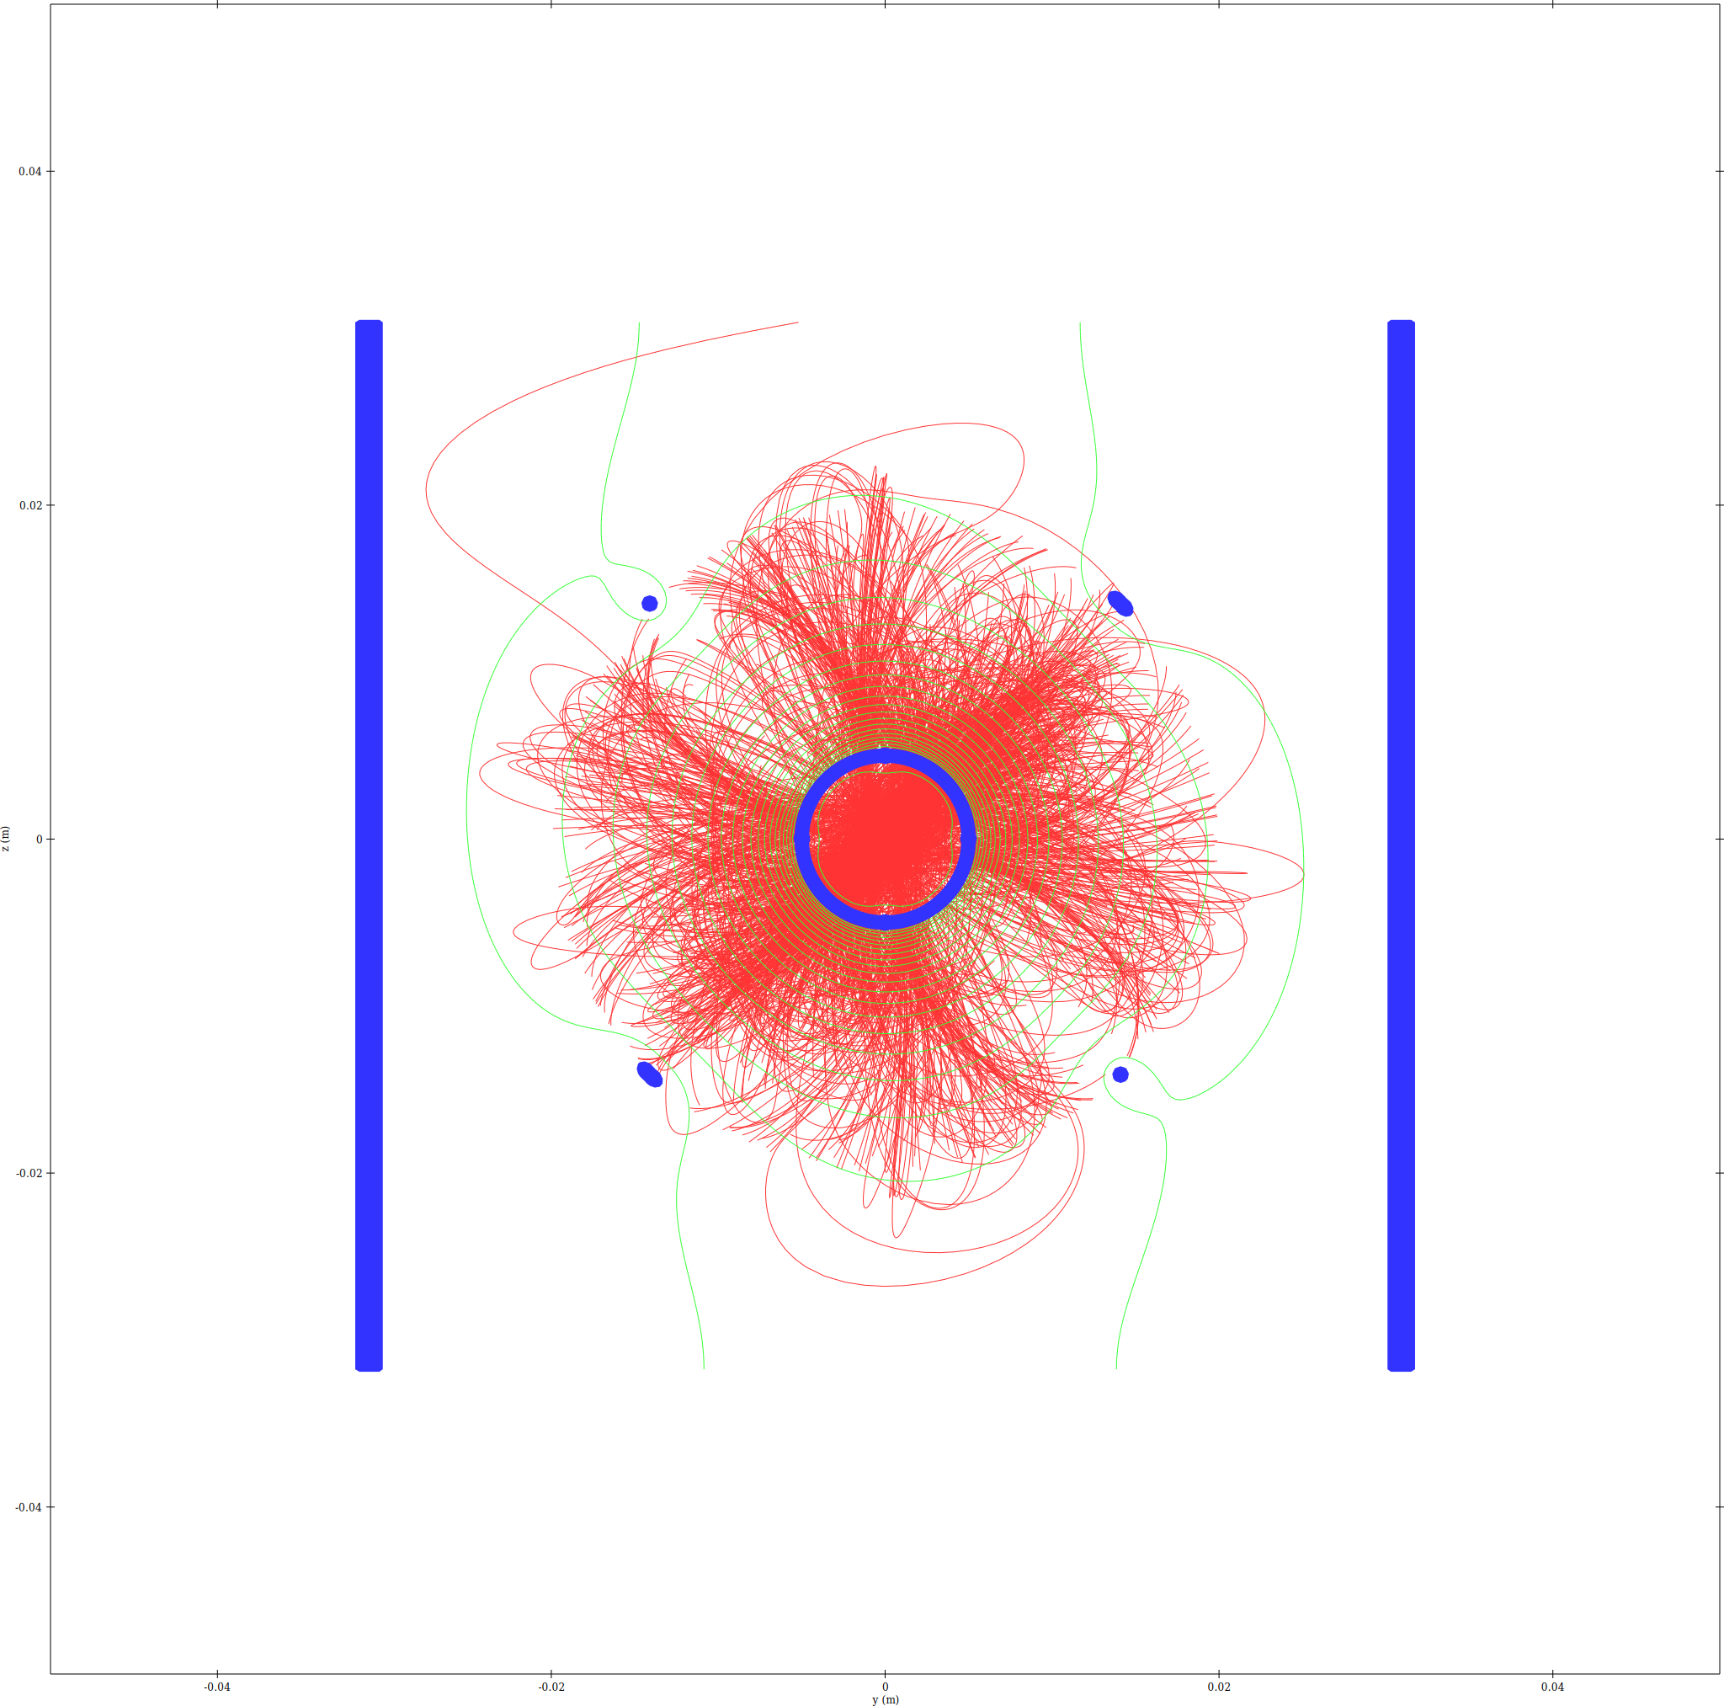
Ion trajectory density - YZ_X0 slice

Electrons
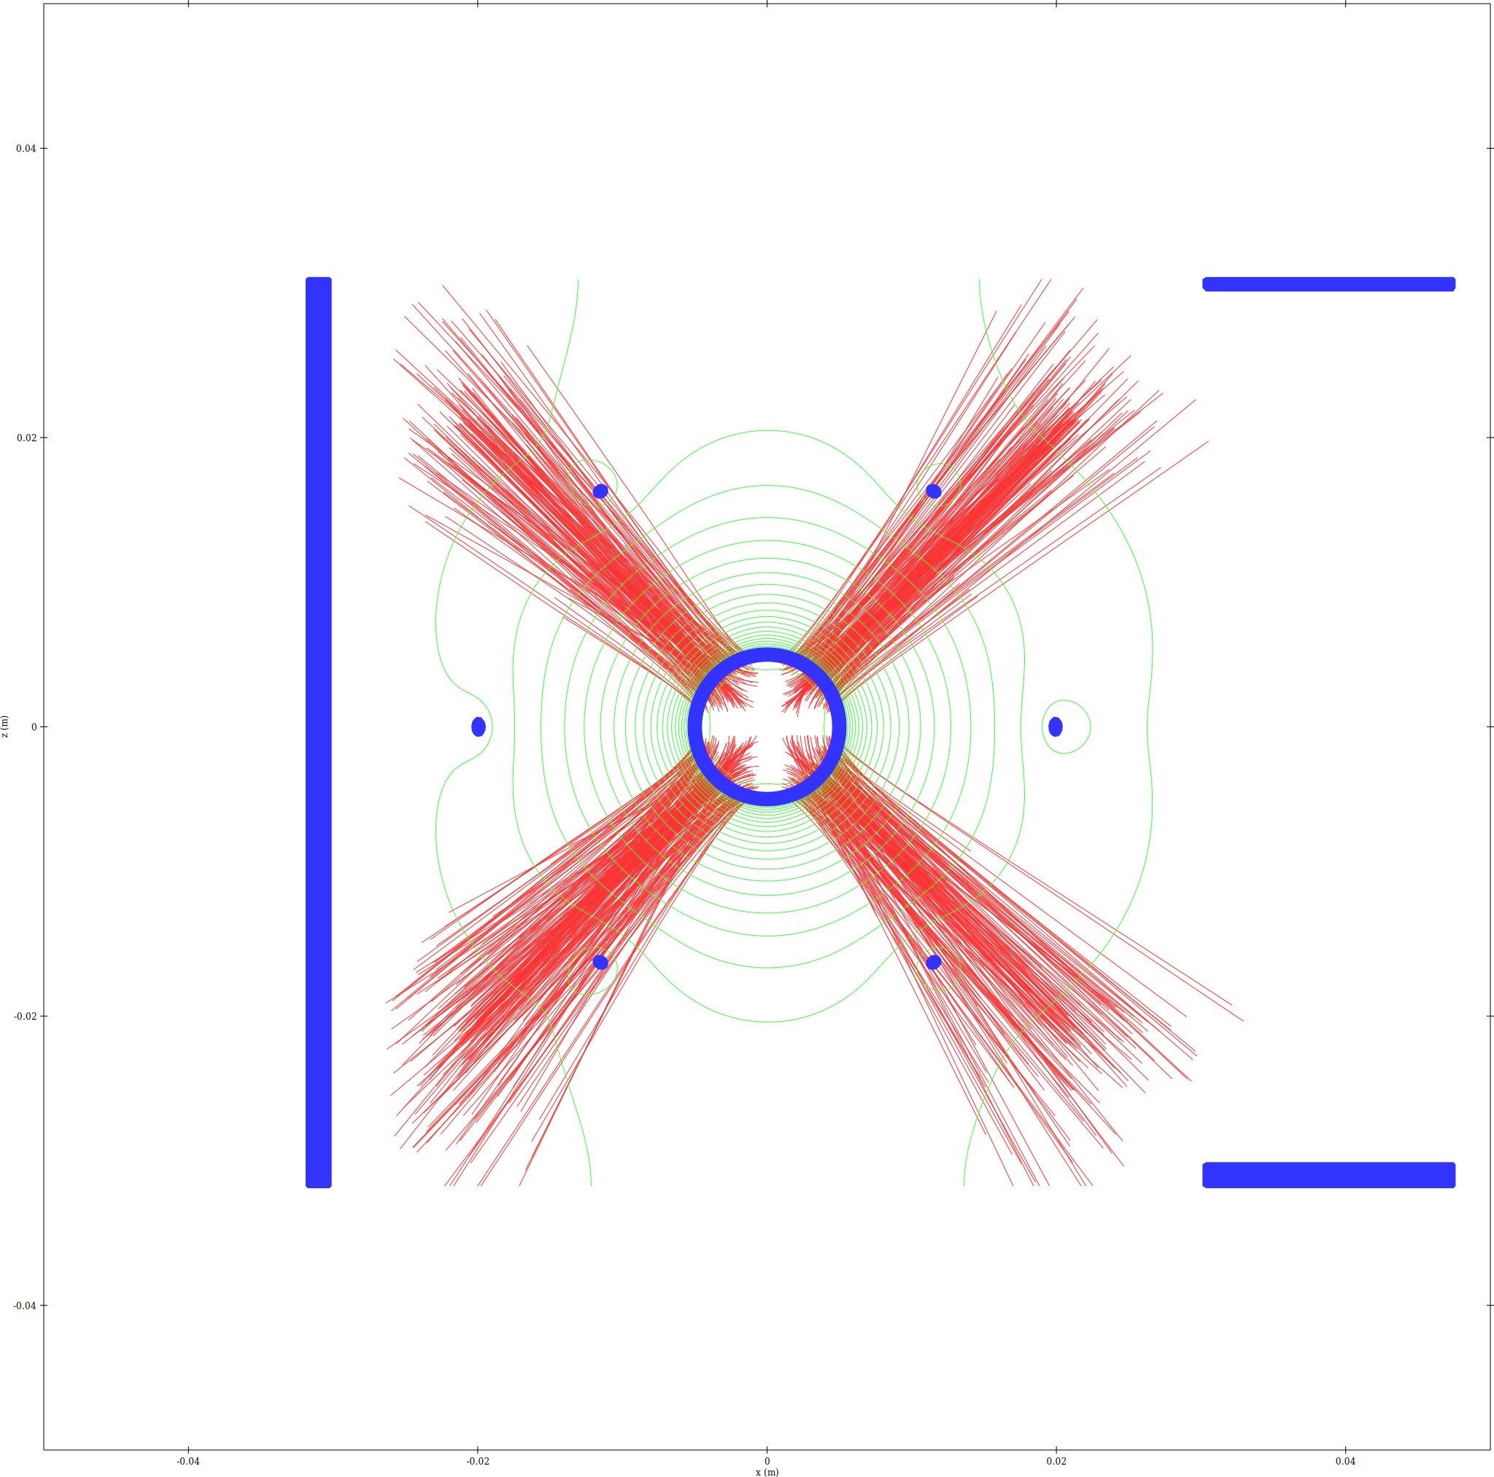
Electron trajectory density - XZ slice
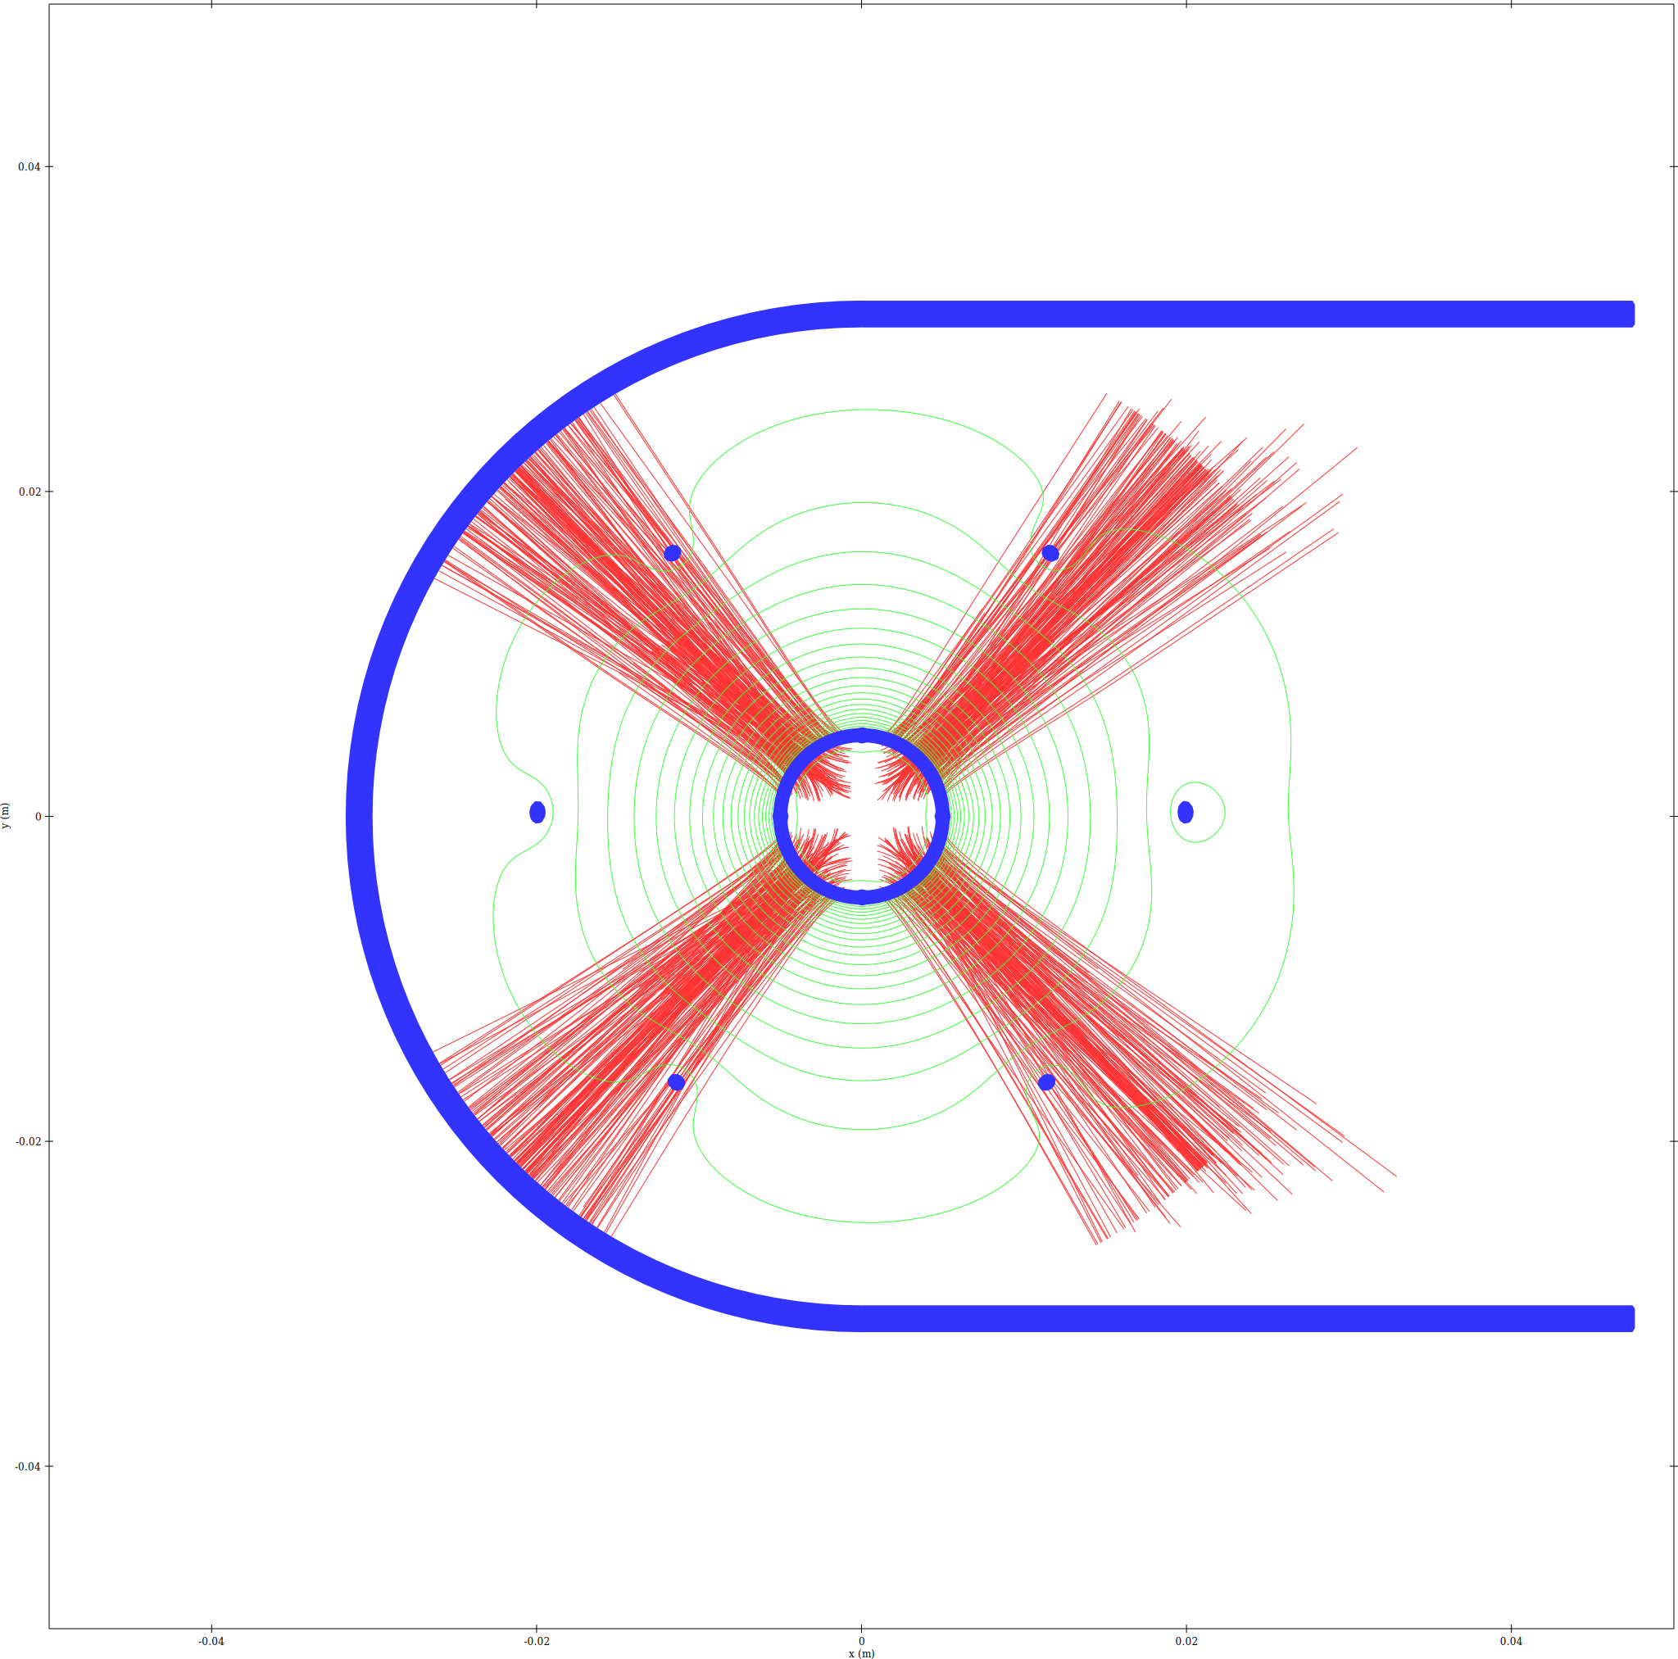
Electron trajectory density - XY slice
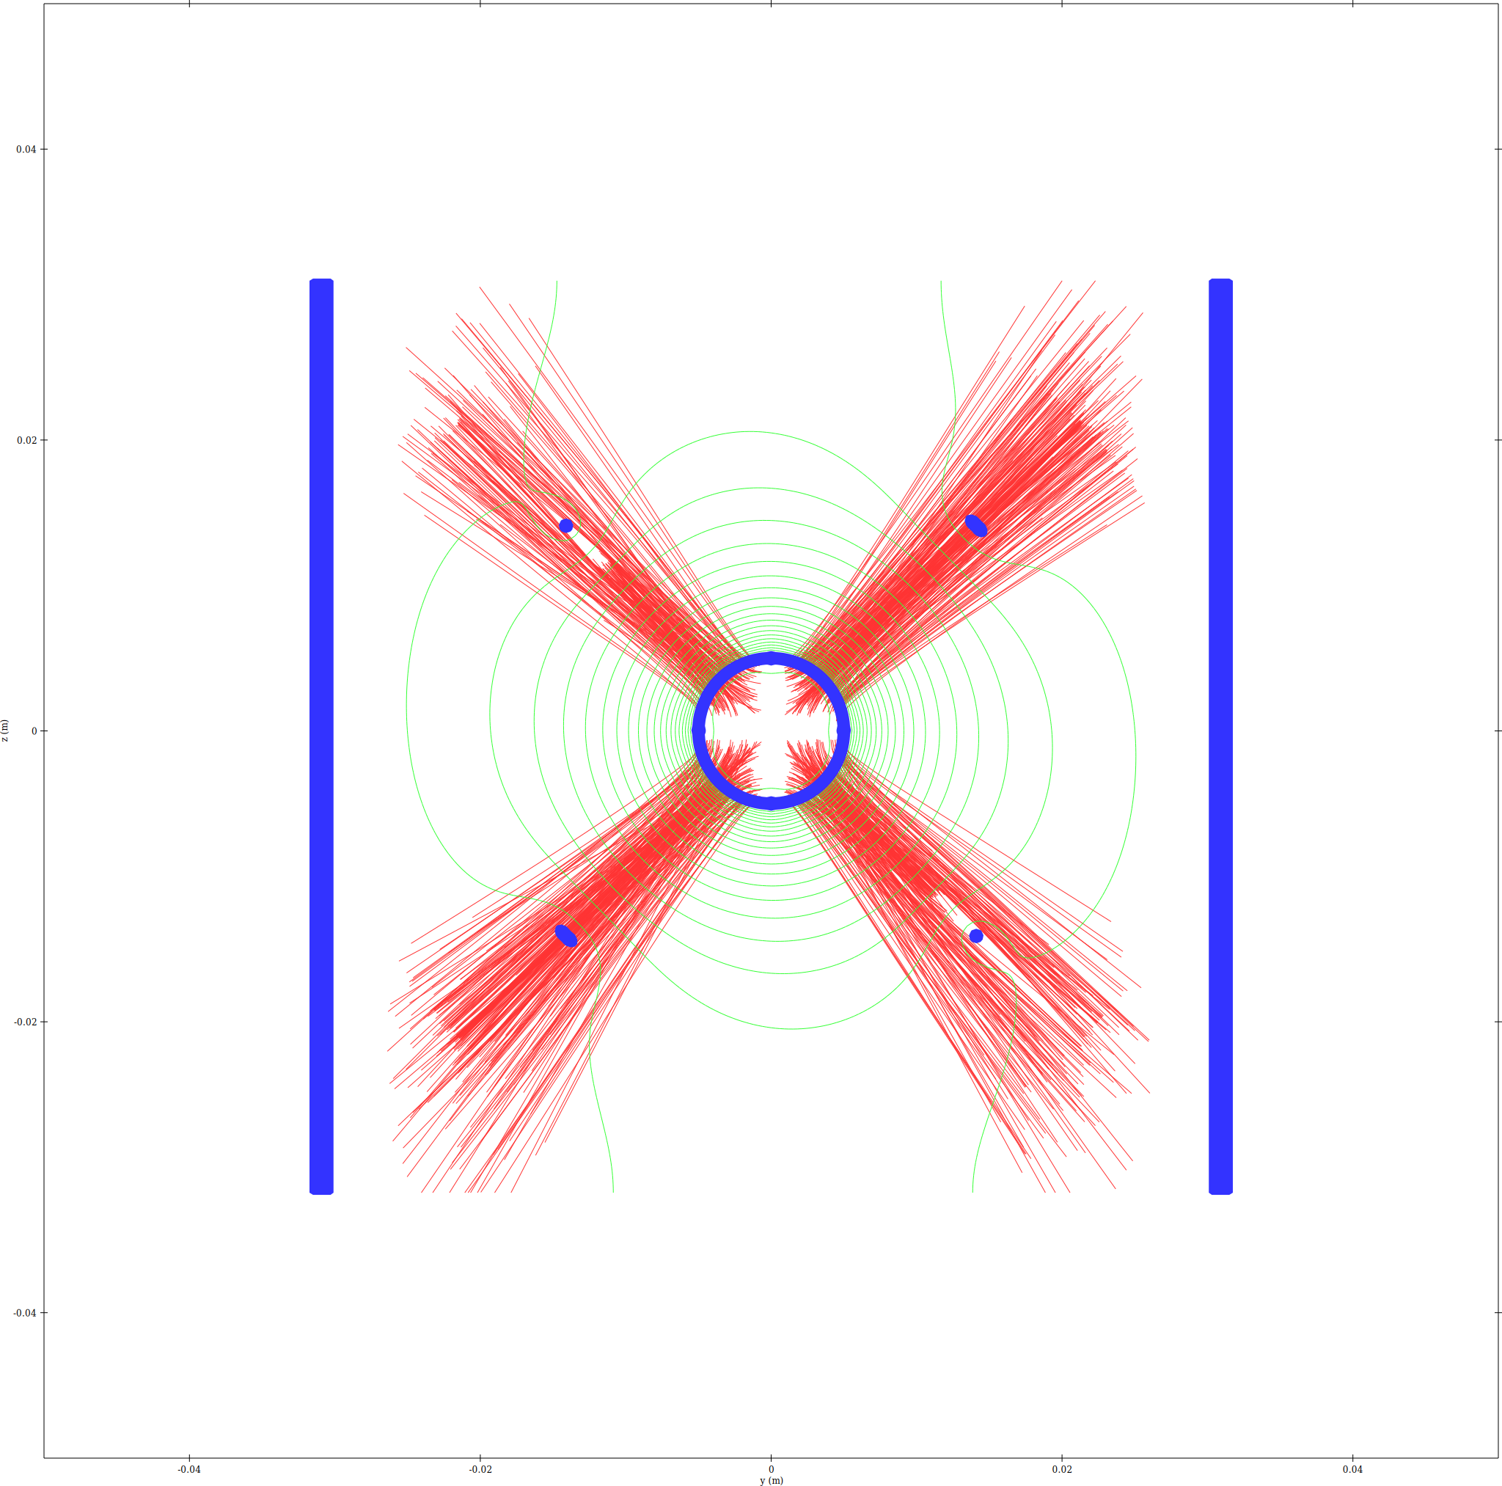
Electron trajectory density - YZ_X0 slice

Combined (ions=red, electrons=blue, overlap=magenta)
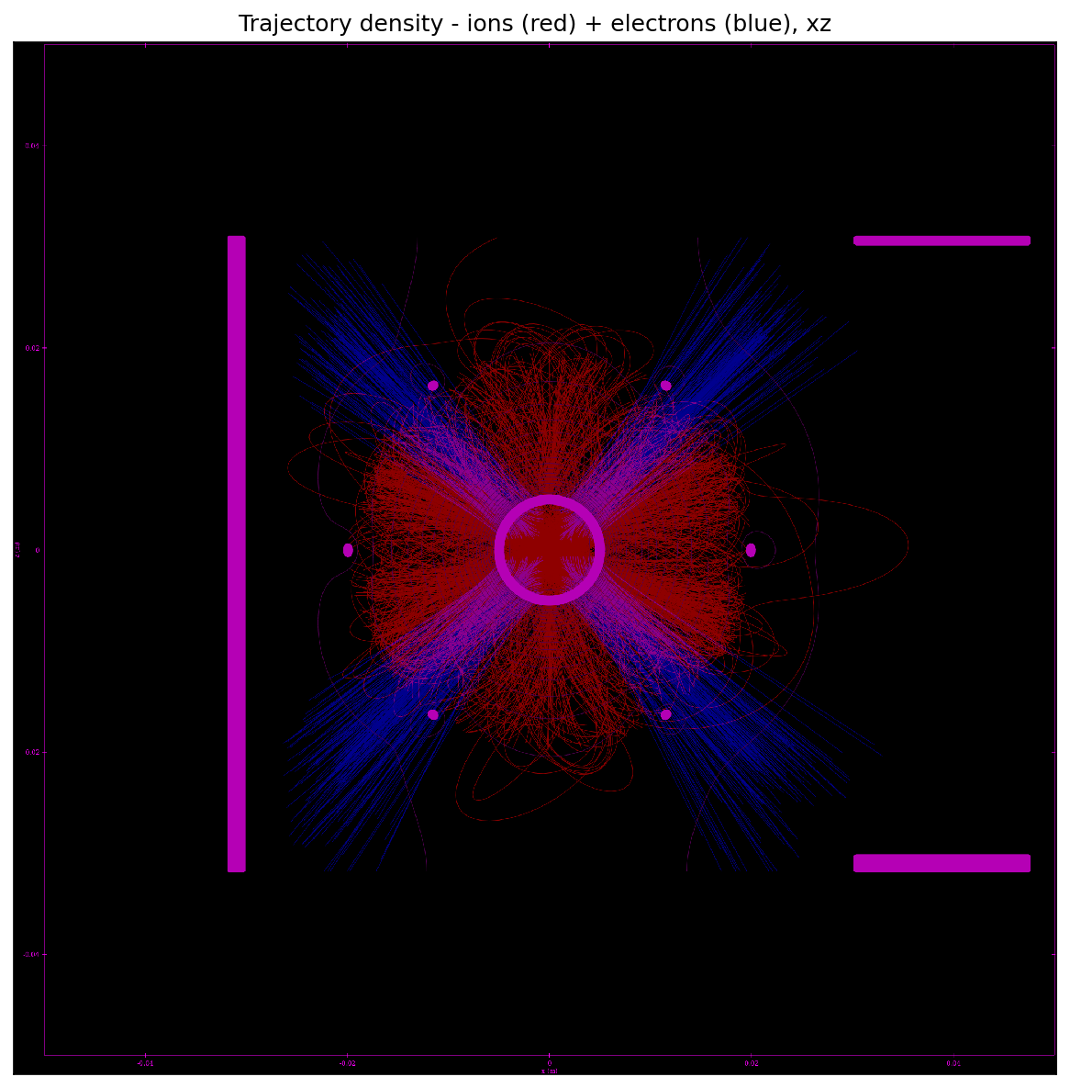
Combined trajectory density - XZ slice
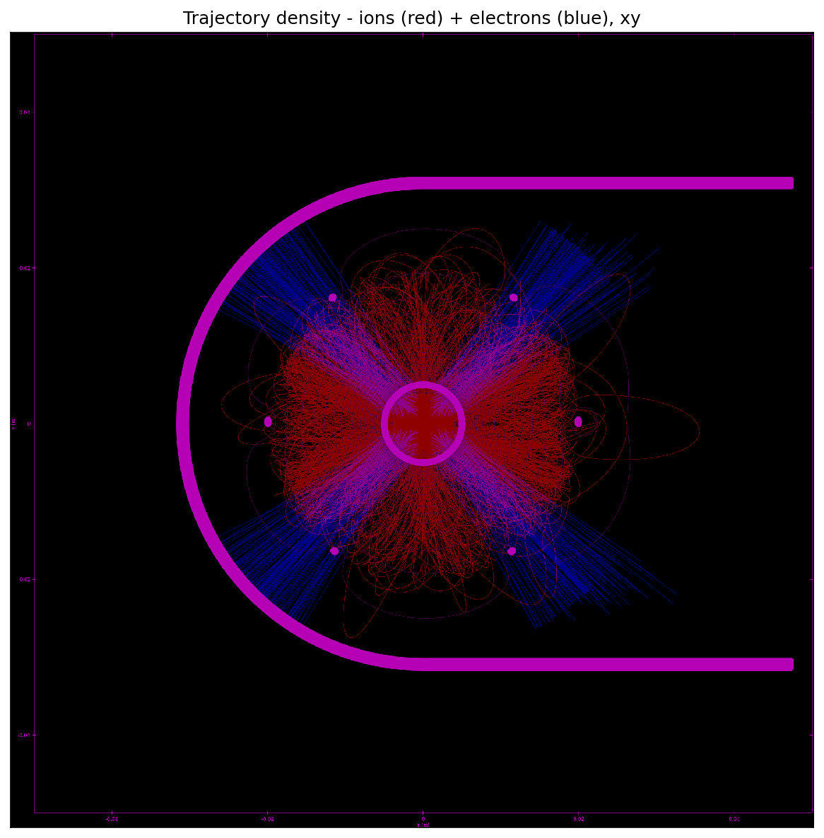
Combined trajectory density - XY slice
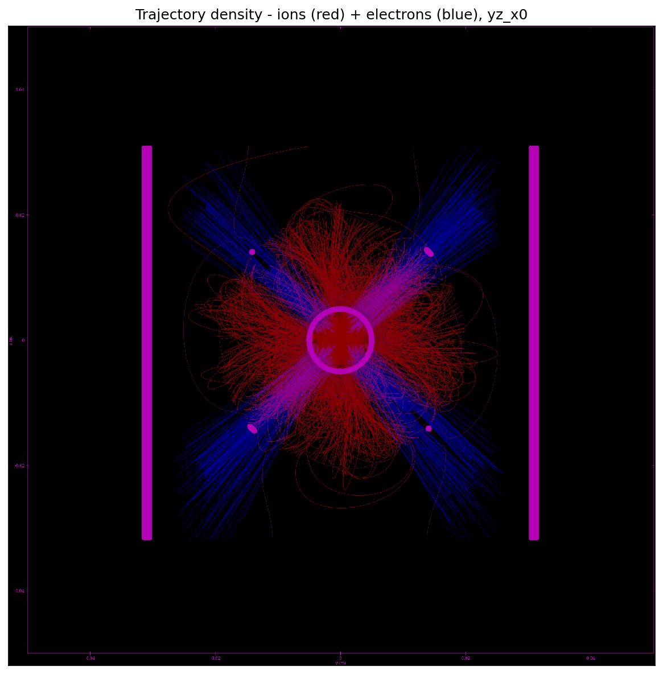
Combined trajectory density - YZ_X0 slice

Memory Estimate
Memory breakdown for run22/
N_clouds (ions) = 800000
N_clouds_e (electrons) = 800000
bytes/particle = 108, bytes/step = 56
Mesh nodes = 17808000 (4 scalar + 1 vector(3) fields)
Mesh-field memory = 0.929 GB
Solver workspace est. = 1.858 GB
Geometry est. = 0.066 GB
Constant overhead total = 2.853 GB
Particle data (constant) = 0.161 GB
iteration | ion_steps | e_steps | traj_MB | overhead_MB | total_GB
1 | 81599271 | 31863335 | 6059.56 | 3085.88 | 8.9311
2 | 83116371 | 34047346 | 6257.22 | 3085.88 | 9.1241
3 | 83086236 | 33862992 | 6245.76 | 3085.88 | 9.1129
4 | 83228483 | 33877587 | 6254.14 | 3085.88 | 9.1211
5 | 82919989 | 33860724 | 6236.76 | 3085.88 | 9.1041

Convergence
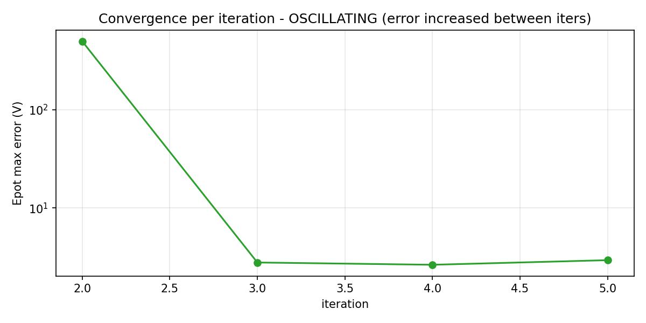
Epot max error per iteration (oscillation flag in title if error grew between iters)
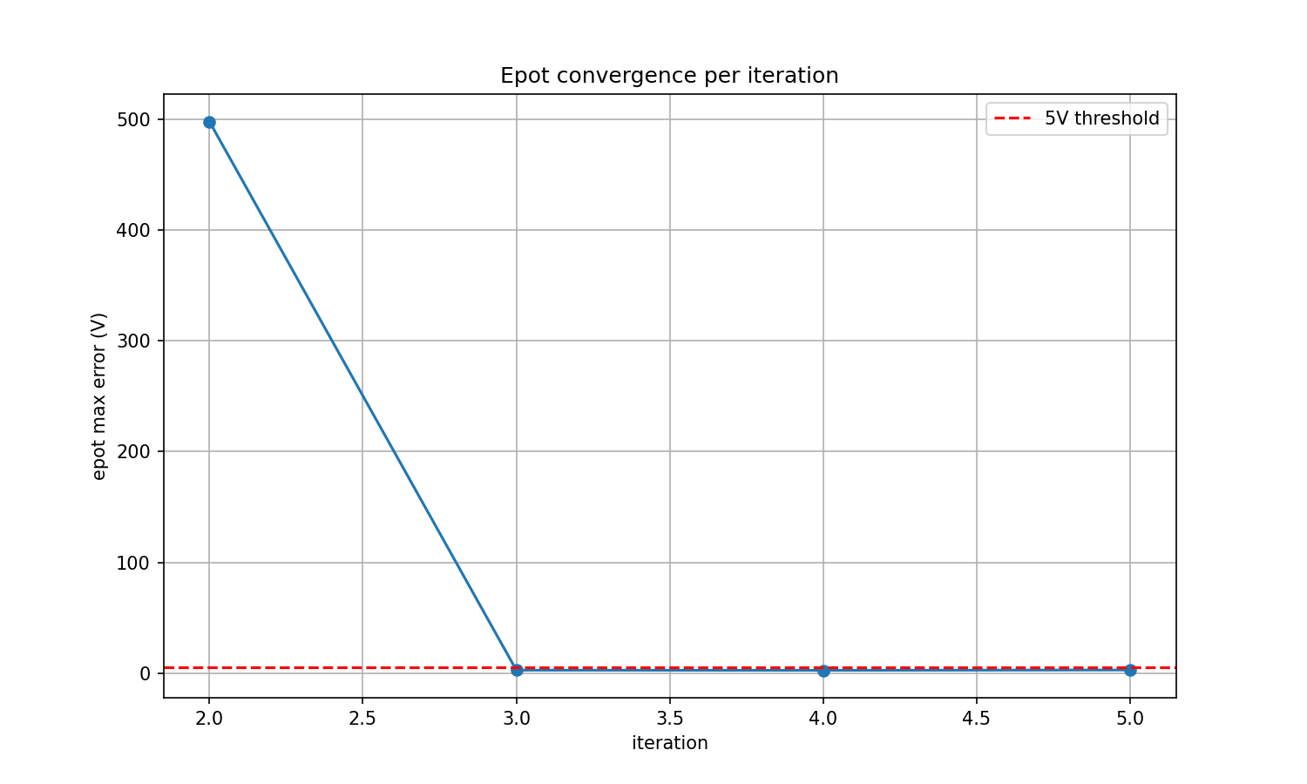
Epot max error vs iteration (postprocess plot)

